NETFLIX TITLE SQL REPORT
- Display first 10 rows
SELECT TOP 10 * FROM netflix_titles
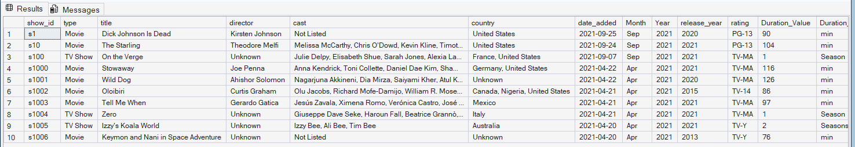
- Total row count
SELECT COUNT(*) AS total_rows FROM netflix_titles
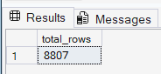
- SELECT COLUMN_NAME, DATA_TYPE, CHARACTER_MAXIMUM_LENGTH
FROM INFORMATION_SCHEMA.COLUMNS
WHERE TABLE_NAME = 'netflix_titles'
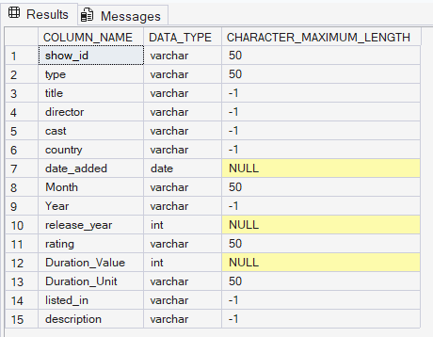
- Count nulls per column
SELECT
SUM(CASE WHEN director IS NULL THEN 1 ELSE 0 END) AS null_director,
SUM(CASE WHEN cast IS NULL THEN 1 ELSE 0 END) AS null_cast,
SUM(CASE WHEN country IS NULL THEN 1 ELSE 0 END) AS null_country,
SUM(CASE WHEN date_added IS NULL THEN 1 ELSE 0 END) AS null_date,
SUM(CASE WHEN rating IS NULL THEN 1 ELSE 0 END) AS null_rating,
SUM(CASE WHEN Duration_Value IS NULL THEN 1 ELSE 0 END) AS null_duration
FROM netflix_titles
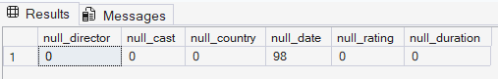
- -- Check for duplicate show_ids
SELECT show_id, COUNT(*) AS cnt
FROM netflix_titles
GROUP BY show_id
HAVING COUNT(*) > 1

- Identify erroneous values in rating column
SELECT show_id, title, rating, Duration_Value
FROM netflix_titles
WHERE rating NOT IN (
'G','PG','PG-13','R','NC-17',
'TV-Y','TV-Y7','TV-Y7-FV','TV-G','TV-PG',
'TV-14','TV-MA','NR','UR'
) OR rating IS NULL
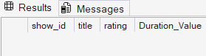
- -- Movies vs TV Shows count
SELECT type, COUNT(*) AS total
FROM netflix_titles
GROUP BY type
ORDER BY total DESC
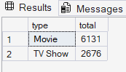
- Content added per year
SELECT
YEAR(CAST(date_added AS DATE)) AS year_added,
COUNT(*) AS titles_added
FROM netflix_titles
WHERE date_added IS NOT NULL
GROUP BY YEAR(CAST(date_added AS DATE))
ORDER BY year_added
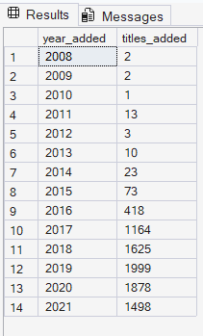
- Top 10 countries by number of titles
SELECT TOP 10 country, COUNT(*) AS total
FROM netflix_titles
WHERE country IS NOT NULL
GROUP BY country
ORDER BY total DESC
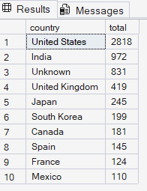
- -- Rating distribution
SELECT rating, COUNT(*) AS count,
ROUND(COUNT(*) * 100.0 / SUM(COUNT(*)) OVER(), 2) AS pct
FROM netflix_titles
GROUP BY rating
ORDER BY count DESC
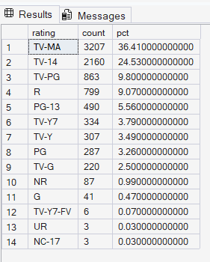
- Top 10 directors by number of titles
SELECT TOP 10 director, COUNT(*) AS titles
FROM netflix_titles
WHERE director NOT IN ('Unknown') AND director IS NOT NULL
GROUP BY director
ORDER BY titles DESC

- Adult vs family content ratio
SELECT
CASE
WHEN rating IN ('TV-MA','R','NC-17') THEN 'Adult'
WHEN rating IN ('TV-Y','TV-Y7','G','TV-G','PG') THEN 'Family'
ELSE 'Teen/General'
END AS audience,
COUNT(*) AS total,
ROUND(COUNT(*) * 100.0 / SUM(COUNT(*)) OVER(), 1) AS pct
FROM netflix_titles
GROUP BY
CASE
WHEN rating IN ('TV-MA','R','NC-17') THEN 'Adult'
WHEN rating IN ('TV-Y','TV-Y7','G','TV-G','PG') THEN 'Family'
ELSE 'Teen/General'
END
ORDER BY total DESC
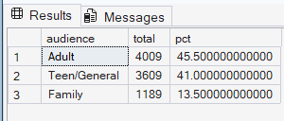
- Oldest and newest titles
SELECT TOP 5 title, type, release_year, country
FROM netflix_titles
ORDER BY release_year ASC;

SELECT TOP 5 title, type, release_year, country
FROM netflix_titles
ORDER BY release_year DESC


